
How to Add a New User
Survey Automator guide

How to Add a New User
Guide Getting started and login

Step 1.
From the home view, click the Show users button located next to + New Project.
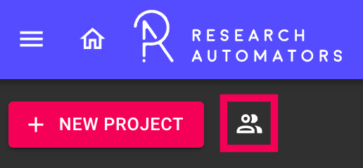

Step 2.
Click + Add User → Add User. The Add window will open.
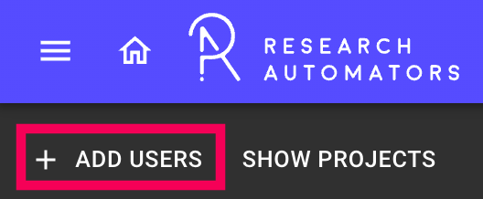

Step 3.
Fill in the user's details under the User section:
- First name
- Last name
- E-mail (required)
- Mobile phone
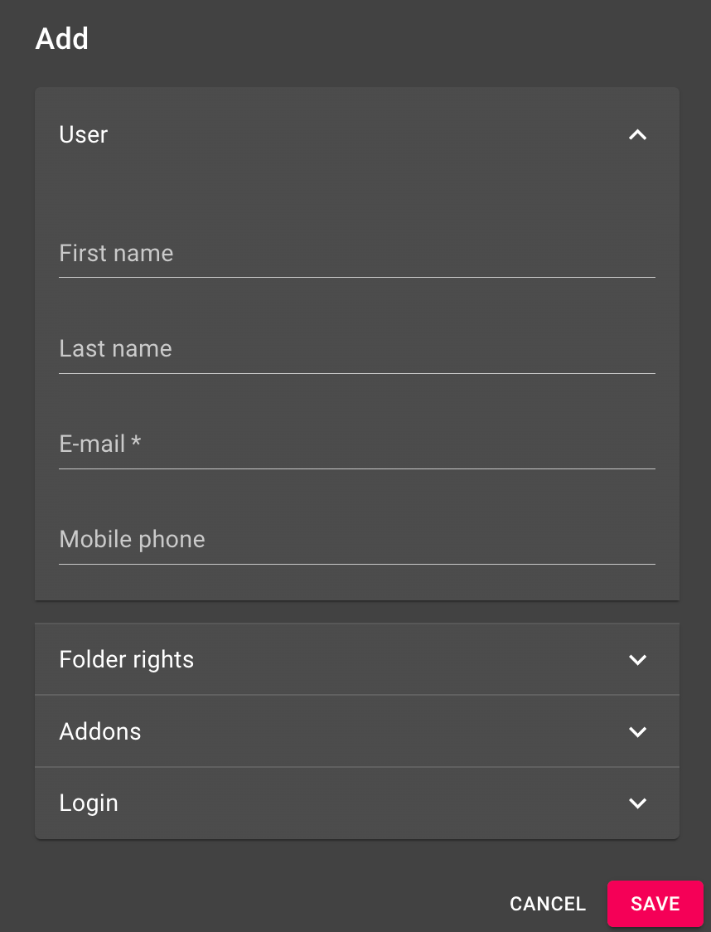

Step 4.
Click Save.

Step 5.
Send the invitation to the User by clicking the Send-icon. The invitation will arrive to the user’s email inbox.
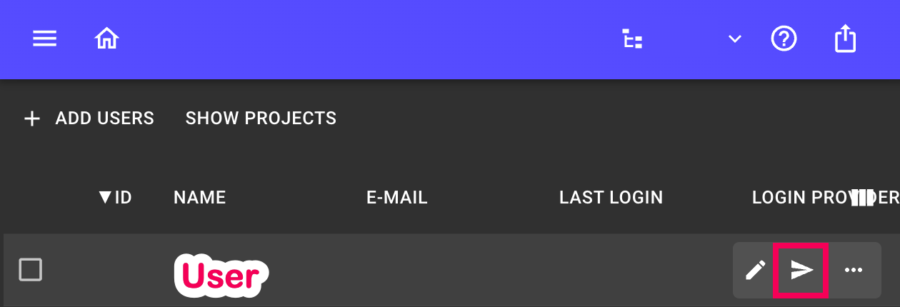
The latest version of this guide: https://www.researchautomators.com/guides/add-a-new-user/

