
How to Copy (Duplicate) a Single Report Page into Another Report
Survey Automator guide

How to Copy (Duplicate) a Single Report Page into Another Report
Guide Report
If you want to copy one specific report page (not the entire report) into another report, you do this from the Page list view using the Duplicate into action.

Prerequisites
- You have access to the project’s Report area.
- The destination report is in the same project (this function works within a project).

Step-by-Step Instructions
- Open the Report tab
  - Go to your project and open the Report tab.
- Switch to Page list view
  - Press Ctrl + L to switch to the Page list.
  - Alternatively, click the gear icon in the top-right corner and select Page list.
- Select the page you want to copy
  - In the Page list, click the row for the page you want to duplicate.
  - You can also select multiple pages if needed.
- Click “Duplicate into”
  - Click the Duplicate into icon (the duplicate/copy action in the toolbar above).
  - A dropdown/list will appear.
- Choose the destination report
  - From the list, select the report you want to copy the page into.
  - The system will duplicate the selected page(s) into the chosen report.
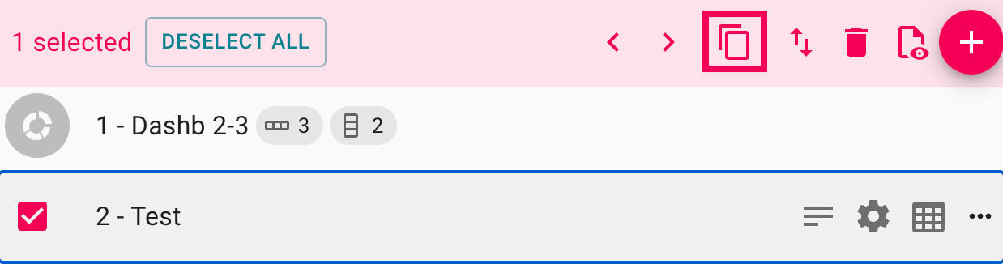
The latest version of this guide: https://www.researchautomators.com/guides/copy-report-page/

