
New User Login
Survey Automator guide

New User Login
Guide Getting started and login
You will receive an email from the @researchautomators.com domain with instructions on how to log in.

Follow these steps:
- Click on " Create account" ****in the email or go to the link:
https://app.researchautomators.com/CoAction/Logon.aspx?action=setpsw
- Enter the email address you used to register with us:
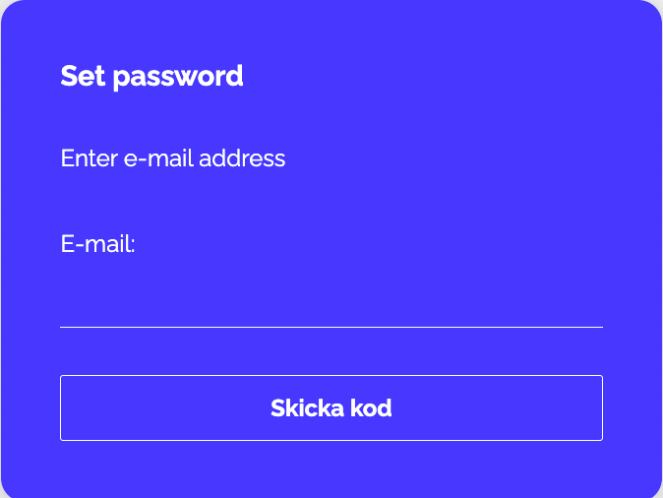
- You will then receive a new email with a verification code. Copy and paste it to continue.
Check your spam folder if the email hasn’t arrived within a few minutes
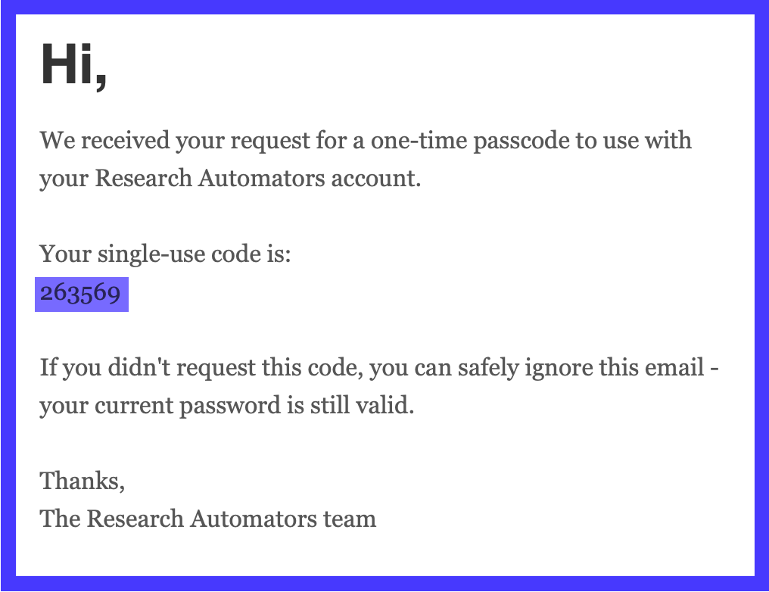
- Enter the verification code.
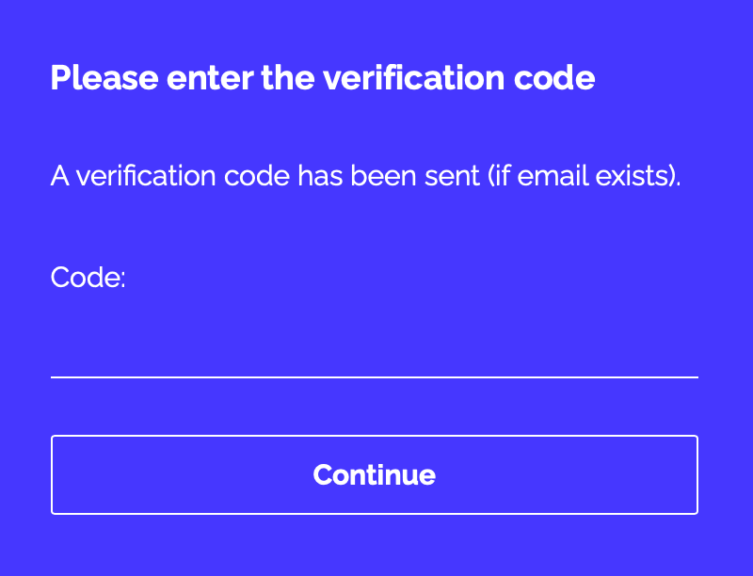
- Set up a verification method. You can link your Microsoft account, BankID, or both. If you choose Microsoft, you can log in immediately; if you choose BankID, simply scan the QR code.
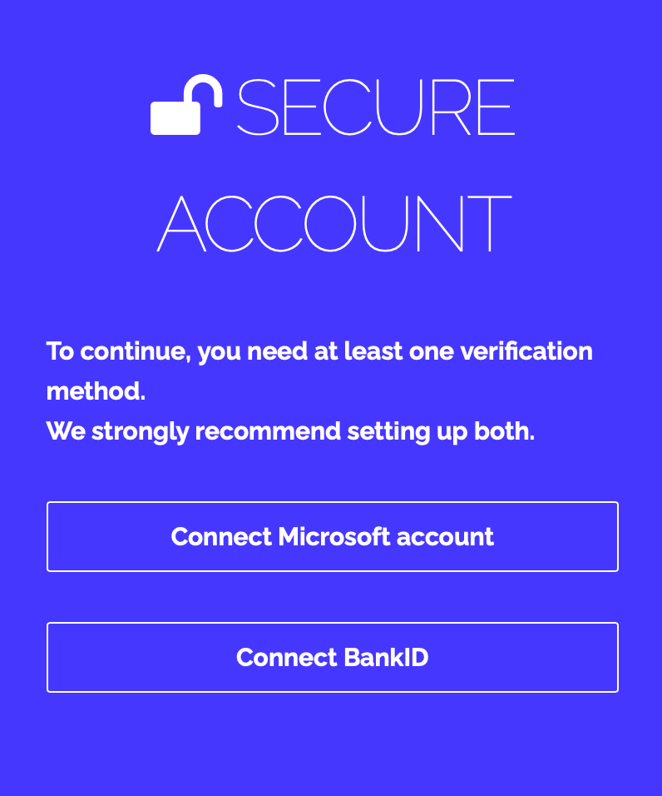
- After linking one or both, click Go to system.
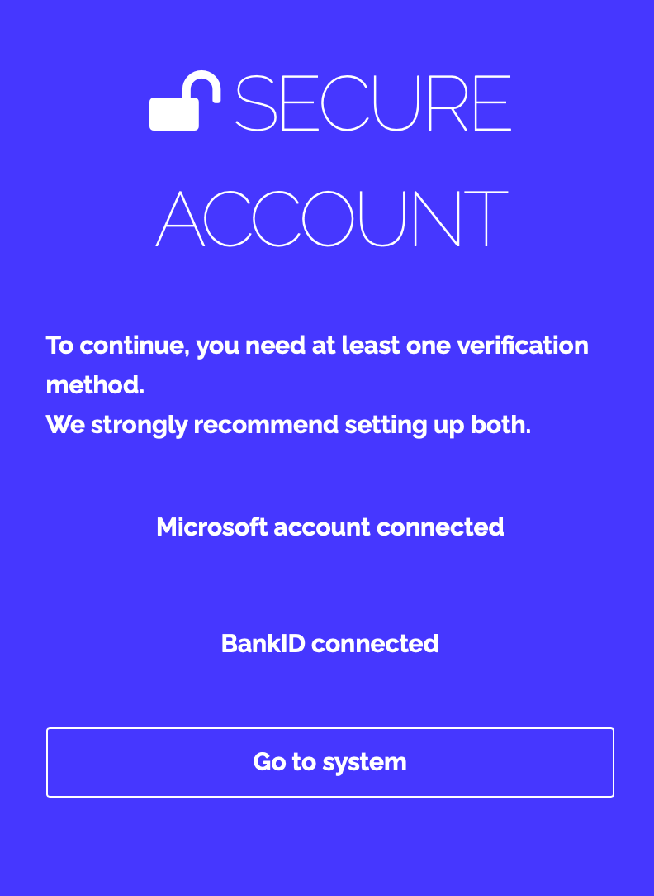
- Now choose how you want to log in, and you’ll be taken directly to the platform.
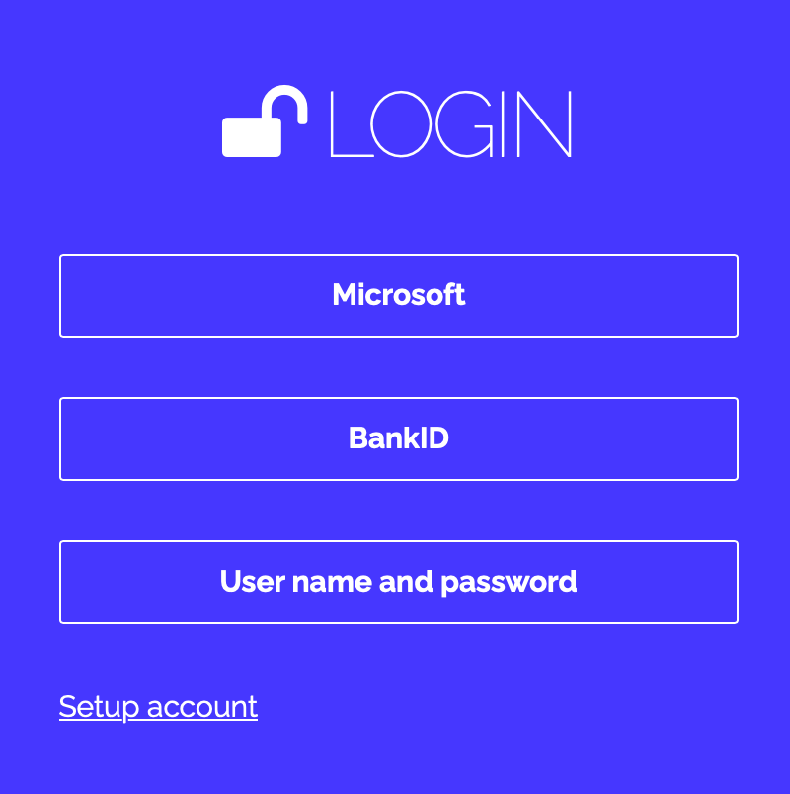
The latest version of this guide: https://www.researchautomators.com/guides/new-user-login/

