
Sign in without BankID or access to your cell phone
Survey Automator guide

Sign in without BankID or access to your cell phone
Guide Getting started and login
If you can't use BankID or your cell phone, you can log in by setting up your account with a verification code sent via email.
Step 1:
Click: Set up account
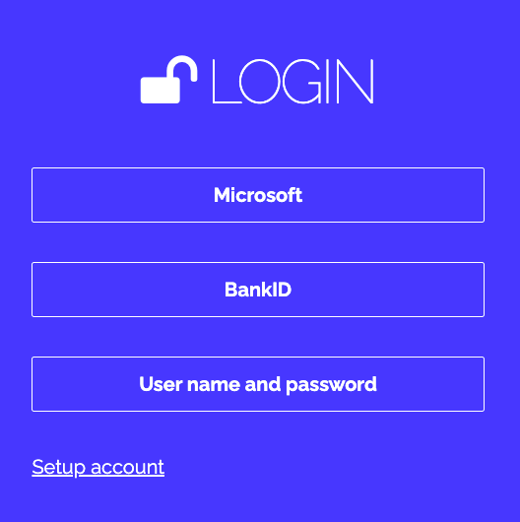
Step 2:
Enter your name and click “Send code”
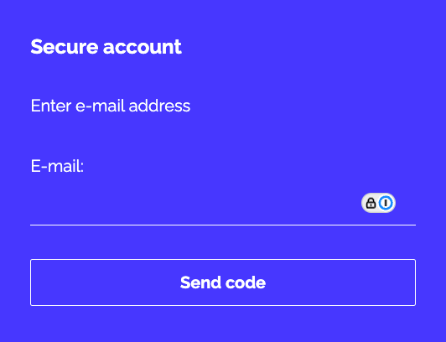
Step 3:
Copy the code from the email and paste it
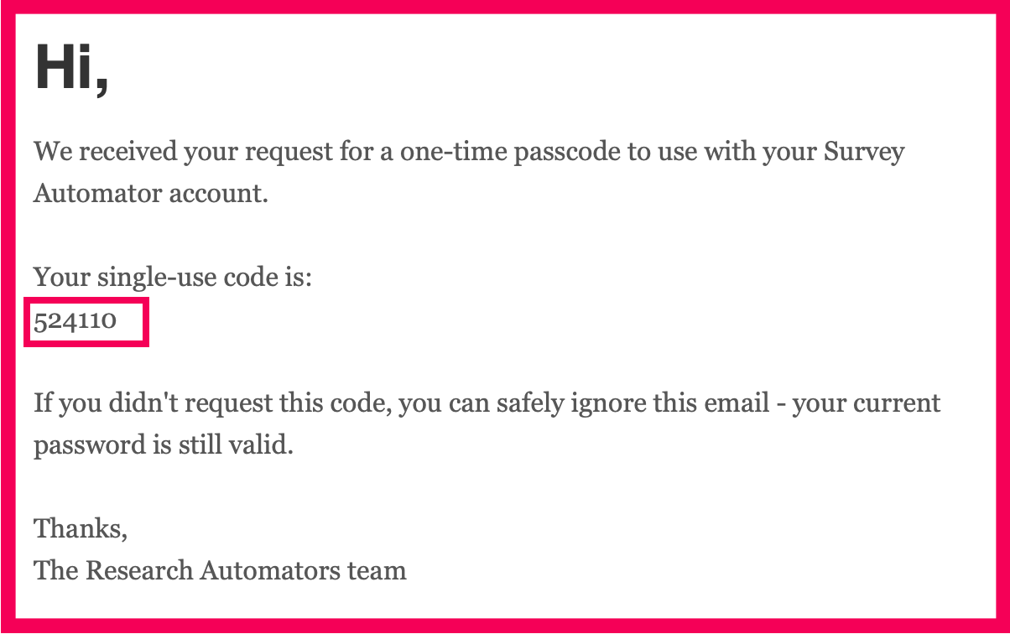
Step 4:
Select a new verification method or choose " Go to system"
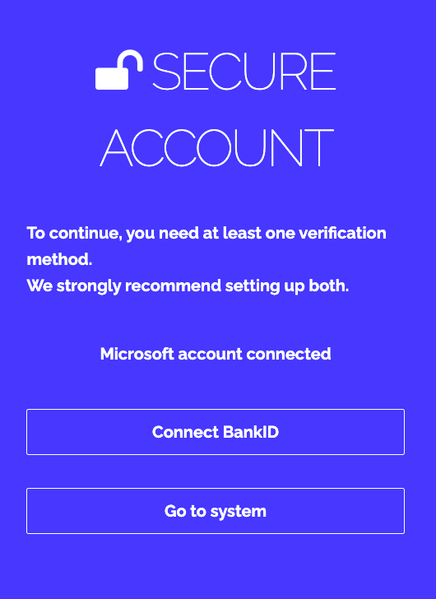
The latest version of this guide: https://www.researchautomators.com/guides/sign-in-without-bankid/

